MODULE-Ⅰ

INTODUCTION TO SOLAR ENERGY TECHNOLOGY

[Draw your reader in with an engaging abstract. It is typically a short summary of the document. When you’re ready to add your content, just click here and start typing.]

SOLAR ENERGY

INTRODUCTION

# **INTRODUCTION TO SOLAR ENERGY TECHNOLOGY**

**Solar energy** is radiant light and heat from the sun that is harnessed using a range of technologies such as solar power to generate electricity, solar thermal energy (including solar water heating), and solar architecture. It is an essential source of renewable energy, and its technologies are broadly characterized as either passive solar or active solar depending on how they capture and distribute solar energy or convert it into solar power.

Active solar techniques include the use of photovoltaic systems, concentrated solar power, and solar water heating to harness the energy. Passive solar techniques include orienting a building to the Sun, selecting materials with favourable thermal mass or light-dispersing properties, and designing spaces that naturally circulate air.

**HOW DOES SOLAR ENERGY WORK???**

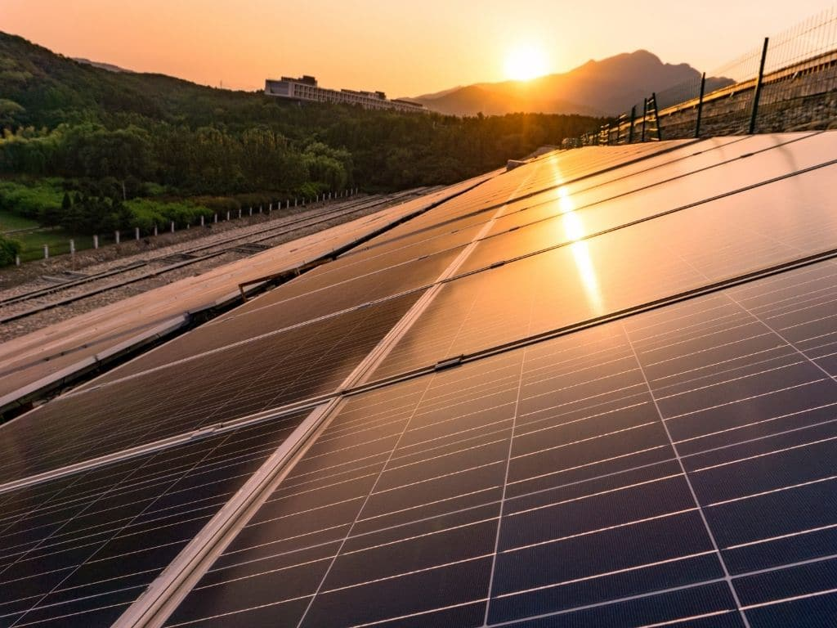

The amount of sunlight that strikes the earth's surface in an hour and a half is enough to handle the entire world's energy consumption for a full year. Solar technologies convert sunlight into electrical energy either through photovoltaic (PV) panels or through mirrors that concentrate solar radiation. This energy can be used to generate electricity or be stored in batteries or thermal storage.

# **ADVANTAGES AND DISADVANTAGES OF PHOTO VOLTAIC SYSTEMS**

In the race to reach net-zero emissions, countries around the world are looking to scale up and eventually depend on renewable energy to substitute polluting fossil fuels. Solar is the most abundant, fastest, and cheapest energy source on Earth, and it generates minimal greenhouse gas emissions. Although this renewable energy is rapidly growing across the globe, with an increasing number of countries investing in it, there are some factors that could hinder its growth. What are the main advantages and disadvantages of solar energy?

|  |  |
| --- | --- |
| **ADVANTAGES** | **DISADVANTAGE** |
| 1. Solar Is a Renewable Energy Source | 1.Solar energy panel needs a lot of spaces. |
| 2. Solar Energy is Immensely Abundant | 2. Solar Energy is Weather Dependent |
| 3. Solar Technologies Are Getting More Efficient | 3. DC equipments are expensive |
| 4. Solar Panels Are Getting Cheaper | 4. Solar Energy is Still Expensive for Households |
| 5. Solar Life Cycle Generates Minimal Greenhouse Gas Emissions | 3. Solar Power Plants Are Not the Most Environmentally Friendly Option |

## **Despite all the disadvantages, Should We Still Invest in Solar Energy?**

The short answer is yes. There is no such thing as a ‘perfect’ energy source. From nuclear and fossil fuels to renewable resources, all of them have many advantages but also some disadvantages, solar energy included. However, as we are quickly running out of time in the race to reach zero emissions, it is crucial that all countries begin to seriously evaluate which sources of energy can bring the most benefits. While solar energy might not be the best solution for northern countries for the lack of sunlight they receive throughout the year, and some of its disadvantages such as the extensive land use that the installation of solar panels requires might not make it the best candidate for everyone, this renewable resource, along with all others, certainly has undeniable potential and it still a better alternative to environmentally unfriendly fossil fuels, beyond being the best chance we have at stopping global warming.

**WHAT IS A SOLAR CELL?**

A **solar cell** (also known as a photovoltaic cell or PV cell) is defined as an electrical device that converts light energy into electrical energy through the photovoltaic effect. A solar cell is basically a p-n junction diode. Solar cells are a form of photoelectric cell, defined as a device whose electrical characteristics – such as current, voltage, or resistance – vary when exposed to light.

Individual solar cells can be combined to form modules commonly known as solar panels. The common single junction silicon solar cell can produce a maximum open-circuit voltage of approximately 0.5 to 0.6 volts. By itself this isn’t much – but remember these solar cells are tiny. When combined into a large solar panel, considerable amounts of renewable energy can be generated.

**CONSTRUCTION OF SOALR CELL:**

A solar cell is basically a junction diode, although its construction it is little bit different from conventional p-n junction diodes. A very thin layer of p-type semiconductor is grown on a relatively thicker n-type semiconductor. We then apply a few finer electrodes on the top of the p-type semiconductor layer.

These electrodes do not obstruct light to reach the thin p-type layer. Just below the p-type layer there is a p-n junction. We also provide a current collecting electrode at the bottom of the n-type layer. We encapsulate the entire assembly by thin glass to protect the **solar cell** from any mechanical shock.

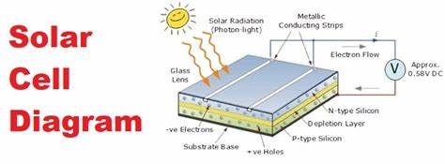

### **V-I Characteristics of a Photovoltaic Cell**

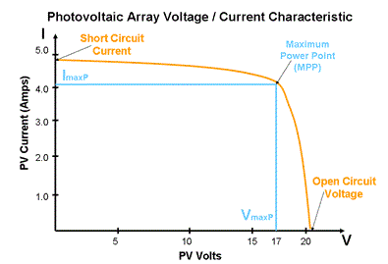

### **Materials Used in Solar Cell**

The materials which are used for this purpose must have band gap close to 1.5ev. Commonly used materials are-

1. Silicon.
2. GaAs.
3. CdTe.
4. CuInSe2

### **Criteria for Materials to be Used in Solar Cell**

1. Must have band gap from 1ev to 1.8ev.
2. It must have high optical absorption.
3. It must have high electrical conductivity.
4. The raw material must be available in abundance and the cost of the material must be low

**MODULE 2:**

**COMPONENTS OF SOLAR POWER PLANT:**

PV cells are made of materials that generate electrons when exposed to light. The electrons flow through a circuit and produce direct current (DC) electricity, which can be used to power various devices or be stored in batteries. Solar panels are also known as solar cell panels, solar electric panels, or PV modules.

Solar panels are usually arranged in groups called arrays or systems. A photovoltaic system consists of one or more solar panels, an inverter that converts DC electricity to alternating current (AC) electricity, and sometimes other components such as controllers, meters, and trackers. A photovoltaic system can be used to provide electricity for off-grid applications, such as remote homes or cabins, or to feed electricity back into the grid and earn credits or payments from the utility company. This is called a grid-connected photovoltaic system.

The components of solar power plants are defined below in details:

**1.Solar panels and array:** A Solar panel consists of a number of solar modules, which are connected in series and parallel configuration to provide specific voltage and current to charge a battery. A diode is connected on the positive terminal of such string in forward bias.

**2.Array junction box:** AJB is the interface between the solar panels and the charge controller. All the incoming/outgoing cables/wires from the solar panel to charge controller are terminated at AJB.

**3.Charge Controller:** Charge controller is the interface between array and the battery bank. It protects the battery from overcharging and moderate charging at finishing end of the batter bank. Therefore, it enhances the life of the battery bank. It also indicates the charging status of batteries like battery undercharged, overcharged or deep discharges through LEDs indications. Some switches and MCBs are also provided for manual or accidental cut off of charging. In some charge controllers load terminals are also provided through a low battery charge cut off device so that it can protect the battery bank from deep discharge.

**4.Module Mounting Structure:** This is made up of galvanized iron frames and angles. In this structure, flexibility is provided to change the module-mounting angle seasonally. This structure is grouted small civil work and modules are mounted subsequently. Also, this mounting structure should be earthed suitably at several places if voltage of the array is more than 50 volts. It depends upon:

* Angle of elevation
* Maximum solar ionizing radiation
* Strong framework
* Air cooling

**5.Earthing kit:** Earthing kit provides to earth the mounting structure. Provision of earthing shall be done as follows:

The installation shall have proper earth terminals and shall be properly earthed.

The earth resistance should not be more than 2 ohms.

Earth provided shall preferably be maintenance free using earth resistance improvement material. We require different types of cables to connect module to module, modules to charge controller, charge controller to battery, or connect battery to load as required. The cable size used for interconnection of SPV module, Charge Controller and battery shall be minimum 2 X 2.5 sq. mm Cu. Cable. As far as some hardware is concerned the screws and bolts/nuts are of Chrome plated, stainless steel and brass so that rusting should not be take place.

**6.Cables:** The two main materials used to make solar farm wiring are copper and aluminium. Copper is more conductive than aluminium, which means a copper wire carries more current than an aluminium wire of the same size. Aluminium wiring is also more vulnerable to bending and flexing during installation, which can weaken it faster than copper wire. Another challenge with aluminium wire is the higher maintenance costs. Aluminium is more susceptible to temperature extremes. The expansion and contraction of the metal will require a technician to periodically tighten the terminals where aluminium is used. The main benefit to using aluminium is that the up-front cost is cheaper than copper.

**Types of Solar panels:**

Solar panels are classified on the basis of the following points:

* + Crystalline Silicon (Mono/Poly/Amorphous)
  + Different Size or Area of cells
  + Type of cells & nos. (Rectangular/Circular/Square/ Pseudo-square/Semi-circular etc.)
  + Power (High/Mid/Low range)

**7.Battery:** The Sun is not always available and it is not regular. However, loads are to be fed any time of the day. Therefore, power should be stored in a battery bank. Low maintenance Lead acid battery as per IRS: S 88/2004 or latest of specified capacity will be provided. The capacity of this battery bank is given in Ampere - Hour(AH) and bus bar voltage. The bus-bar voltage is decided by the voltage requirement of the load.

**8.Grid-Support:** Solar-grid integration is the technology that allows large scale solar power produced from PV or CSP system to penetrate the already existing power grid. This technology requires careful considerations and attention including in areas of solar component manufacturing, installations and operation.

# MODULE-3

SOME DEFINATIONS:

SOLAR CELL: A **solar cell** (also known as a photovoltaic cell or PV cell) is defined as an electrical device that converts light energy into electrical energy through the photovoltaic effect.

SOLAR MODULE: A solar module is a collection of solar cells that work primarily to absorb the sunlight and convert it into usable electricity. A module in a solar panel refers to the arrangement of solar cells in parallel.

SOLAR ARRAYS: An array of anything is an ordered arrangement of objects. Solar panels happen to be objects, and therefore, solar arrays are groups of solar panels. They should probably be more commonly called “solar panel arrays.”

MODULE-4

# **INSTALLATION OF SOLAR PANEL**

**INTRODUCTION:** Solar modules are to be installed firmly and permanently on metallic structures. The structures depend on the application and size of the system. For smaller systems like solar home system, simple module mounting structures are used. For system like solar street lights, solar power street lighting, solar pumps etc. pole mounting solar frames are used. For bigger system like solar power plants and solar powered Railway signaling installations, bigger array mounting structures are used.

**Testing before installation:**

The following table shows typical user’s specifications of different modules:

TABLE

|  |  |  |  |  |  |
| --- | --- | --- | --- | --- | --- |
| Peak Power Output (Pmax)  (watt) | Nominal Voltage  (v) | Open Circuit Voltage (Voc) | Short circuit Current (Isc)  (amp) | Maximum Voltage (Vmax) At Pmax  (v) | Maximum  Current (Imax) at Pmax  (amp) |
| 4 | 6 | >11.5 | >0.63 | 8.5 | 0.47 |
| 4 | 12 | >21 | >0.3 | 16.7 | 0.23 |
| 8 | 12 | >21 | >0.56 | 16.7 | 0.47 |
| 10 | 12 | >21 | >0.70 | 16.7 | 0.59 |
| 12 | 12 | >21 | >0.84 | 16.7 | 0.71 |
| 18 | 12 | >21 | >1.26 | 16.7 | 1.07 |
| 35 | 12 | >21 | >2.4 | 16.7 | 2.09 |
| 40 | 12 | >21 | >2.7 | 16.7 | 2.39 |
| 50 | 12 | >21 | >3.3 | 16.7 | 2.99 |
| 65 | 12 | >21 | >4.0 | 16.7 | 3.89 |
| 70 | 12 | >21 | >4.5 | 16.7 | 4.09 |
| 75 | 12 | >21 | >5.0 | 16.7 | 4.49 |
| 90 | 12 | >21 | >6.0 | 16.7 | 5.38 |

**ABBREVIATIONS:**

Voc: Open Circuit Voltage

Isc: Short Circuit Current

Vmax: Maximum Voltage

Imax: Maximum Current

Pmax: Maximum Power at Standard test condition or Peak Power Output.

The values in the above table are at standard testing conditions such as 25degree cell temperature and 100- Mw/Sq.cm solar radiation. The output will be reduced as temperature rises and intensity of sunlight reduces. Although accurate power is measured with the help of module Tester at supplier’s end, however to check working of module Voc and Isc can be measured at site by simple multi-meter in two different modes i.e. Current mode and Voltage mode when modules is placed in Sunlight. The solar panel is kept in such position that it receives maximum sunlight.

# **INSTALLATION GUIDELINES**

Solar panels can be used to generate electricity for both commercial and home use. In both cases, the Photovoltaic Panel are installed to get maximum possible sunlight and generate maximum electricity from the system.

The installation of Solar Power System involves the following Major Steps:

* Mount Installation
* Installing a solar panel
* Electrical Wiring
* Connection of the system to solar inverter
* Connection of solar inverter and solar battery
* Connecting solar inverter to the Grid
* Start solar inverter

1. **MOUNTING OF SOLAR MODULES:**

There are two types of mounting of solar panel i.e. Roof mount and Ground mount.

**Roof mount:** Roof mounted solar panels are the most common selection for common households. Reason may vary but the main cause is it is cost efficient.

Generally, the roof mounted system are less expensive than the ground mounted systems, because the main structure needed to sustain the panel is the rooftop itself. This saves cost that otherwise would rise higher due to the aluminum or steel structures needed to support ground mounted panels.

**Ground mount**: As the name implies, the solar system will be located on the ground.

The main advantage of ground mounted system is that there is a wide range of options to choose from, depending on the location, needs and the proposed design.

While mounting the solar modules, following points should be considered for getting maximum output from the solar modules.

The first step is to fix the mounts that will support the solar panels. It can be roof or ground mounts depending on the requirement. This base structure provides support and sturdiness. Care is taken on direction in which the PV panels (monocrystalline or polycrystalline) will be installed. The solar panels are generally installed in such a way that they can receiver maximum direct sunlight without shade from any building/trees nearby falling on them at any part of the day.

For countries in Northern Hemisphere, the best direction to face solar panel is south because it gets maximum sunlight. East and West directions will also do. For countries in the southern Hemisphere, the best direction is north.

Again the mounting structure must be slightly tilted. Angle of tilt could be between 18 to 36 degree. Also the solar tracker can be used to increase the conversion efficiency.

1. **INSTALLING A SOLAR PANEL:**

* Civil Foundation Job
* Assembly and Fixing of support structure
* Mounting of solar module on the support structure
* Installation of battery bank
* Interconnection of SPV panel in series and parallel configuration, charge control unit and FJB
* Connection of Battery bank and load
* Earthing of lightening protection unit

1. **ELECTRICAL WIRING:**

Next step is to do the electrical wiring of the modules. Universal connectors like MC4 are used during wiring because these connectors can be connectedeith all type of solar panels. These panels can be electrically connected with each other in the following series.

* **Series Connection:** In this case, the positive wire of one PV module is connected to the negative wire of another module. This type of wiring increases the Voltage match with the battery bank.
* **Parallel Connection:** In this case; the positive to positive and negative to negative connection is done. In this type of wiring, voltage of each panel remains same.

After the connection of the module cable with the correct polarity, closing the junction box and tie the module cable on the module frame.

**4. CONNECTION OF THE SYSTEM TO SOLAR INVERTER:**

Now, the positive wire from the solar panel is connected to the positive terminal of the inverter and the negative wire is connected to the negative terminal of the inverter.

The solar inverter is then connected to the solar Battery and the grid inpuy to produce electricity.

**5. CONNECTION OF SOLAR INVERTER AND SOLAR**

**BATTERY:**

Now, the positive terminal of the battery is connected with the positive terminal of the inverter and the negative to negative. Battert is needed in off grid solar system to store electricity backup.

**6.CONNECTING SOLAR INVERTER TO THE GRID:**

Next step is to connect the solar inverter to the grid. To make this connection, a normal plug is used to connect to the main power switch board that supplies electricity to the home.

**7.START SOLAR INVERTER:**

Now when all the electrical wiring and connections are done, it’s time to start the inverter switch on the main switch. Most solar inverters will have digital display to show the stats regarding generation and usage of solar unit.

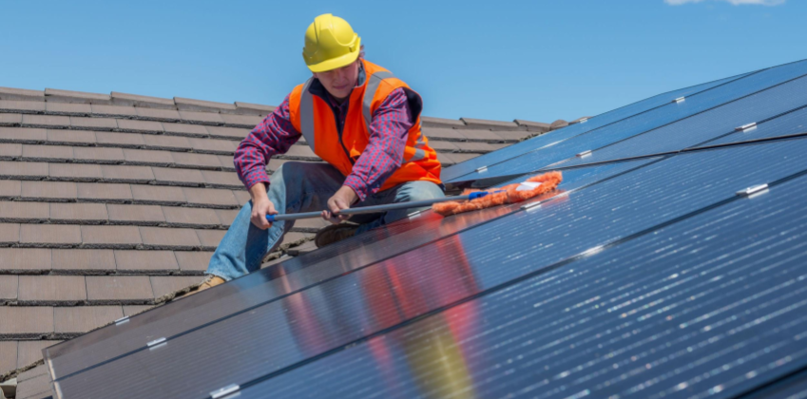 MAINTENANCE

Solar panels typically don’t require much maintenance other than periodic cleaning and keeping them free from obstacles that can cast shadows over the panels. Solar panels need an unobstructed path to the sun to operate optimally.

Solar panels are designed to withstand extreme weather events like hail, snow, ice and wind to provide lasting performance. However, the associated equipments such as batteries, charge controller, wires etc. should be monitored regularly. Solar panels typically have a lifespan of 25 to 30 years with regular maintenance, but should start to see a dip in their output, it might signal it’s time to clean them.

**Precautions and Preventive Steps**

**Please ensure that:**

* SPV Modules are connected in parallel and SPV Panel output voltage is less than 25 Volts under normal sunshine condition (for 12 V System/Module)
* All connections are properly made tight and neat using the crimped Red (for +ve) and Black (for –ve) wires supplied by the manufacturer in order to avoid reverse connection.
* The SPV of the fuse in the charge controller is not charged
* The SPV Panel is installed facing SOUTH and with the correct ‘Angle of tilt’.
* There is no shadow on any part of the SPV Panel at any time of the day, to get maximum power.
* SPV Modules are protected against any act of vandalism and accidental strike or hit by heavy objects, like stone, hammer etc. If the SPV Panel is installed on ground, it must be fenced properly to protect it from cattle and to prevent from any damage/theft. Fencing should be made in such a way that no shadow should fall on SPV Panel at any time of the day.
* Battery Bank is placed on a rack or platform insulated from ground and located in a well-ventilated room and also sufficient clearance is there over the battery.
* FIRST the Battery Bank, then SPV Panel and then Load is connected to SPV charge Control Unit and for disconnection reverse sequence is adopted.
* Battery terminals are never shorted even momentarily as shorting will result in heavy spark and fire. (To avoid the same connect the cable at charge controller end first and then battery end.)
* Never connect the Load directly to the SPV Panel as SPV Panel may give higher/lower voltage than required by the Load Equipment and hence the equipment may be DAMAGED permanently.
* Blocking diode is provided at the array output fot protection against reverse property.
* Make sure that the Solar PV module gets direct sunlight throughout the day where you install it.
* The Green indicator on Charge controller is only an indication for charging. It will glow even at small amount of charging. So to ensure efficient charging, the availability of direct sunlight over the Solar PV module for the maximum hours of the day should be ensured.
* It is not heat but light that produces energy. So let direct sunlight to fall on the module surface without shades.

**TROUBLESHOOTING**

The SPV power source is reliable source of electrical energy. However, there may be rate instances, when the SPV power Source is not able to drive the connected equipment.

The diagnosis of the problem in such situations starts with the battery. Check the voltage of the battery bank. If the voltage of the battery bank is correct as indicated in charge controller, there may be problem in the inverter or switch between load and inverter i.e. either inverter is tripped or switch/load MCB is tripped or load fuse is blown off. If none of the above fault is observed the specific gravity of the electrolyte in the secondary cells of the battery.

CAUSES:

* If the specific gravity is above the level 1.2( Hydrometer reading 1200) value or as specifies a=in the maintenance manual, it Implies that the battery is in order and the problem would be either with the charge controller or load. Disconnect the load (S & T Equipment) from charge controller and connect it directly to the battery bank. If the equipment operates, the defect may be with the charge controller and check asper troubleshooting instructions.

Given in the manual supplied with it or inform the manufacturer/supplier:

* If the specific gravity of the electrolyte is below the problem level and BATT/LOW(red) LED is glowing, the following:

1. Load: This may be drawing more current from the battery than required. In such case, battery is bound to get discharged, even if SPV Panel is functioning properly. This would result in frequent tripping of the load. To avoid this, get the load equipment checked and replace any defective components.
2. SPV Panel: The SPV Panel may not be producing required power for which the power Source has been designed. In that case, check the SPV Panel.

Measure the voltage and current of each module after disconnecting the wire.

1. Failure of blocking diode: Blocking diode fails in short circuit and open circuit mode. If it is failed in short circuit mode, voltage across its terminal will be zero in place of 0.7 V while charging current flows through it. When it fails in open circuit mode, the current will not flow through the diode. The diode may be checked as per standard method of checking of diode by removing from the circuit.

TROUBLESHOOTING FLOWCHART FOR SPV PANEL:

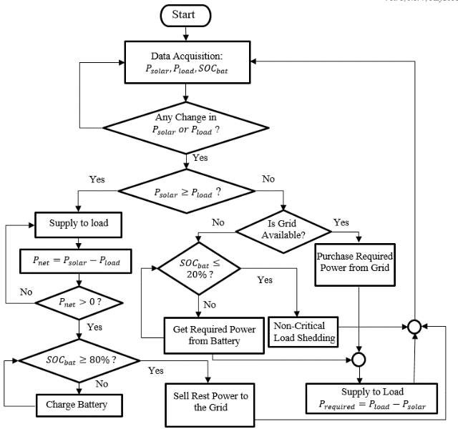

TESTING EQUIPMENTS:

* 1. Test lamps
  2. Prototype Motors
  3. Multimeters
  4. Analog Ammeters
  5. Analog Voltmeters
  6. Digital AHO/Clamp meters
  7. Testing kits
  8. Meggers
  9. Lux Meters
  10. Angle Deflector and MPPT systems
  11. Screw Drivers, other Accessories
  12. Relay kits
  13. Earth Testers
  14. Induction Motors
  15. Analog Energy meters
  16. Digital Energy meters
  17. Measuring Tapes
  18. Drivers and Systems.
  19. Test leads
  20. Wire Conduits , cutters and gauge conversion meters.

**DONE**

CONCLUSION:There is a cost associated with electrifying houses in rural areas that increases with distance between the grid and the houses. Such instances where the cost of electrification becomes enormously highly one can always use an off-grid PV system. Both type of systems viz. grid- tied and off-grid PV systems have their own advantages and disadvantages. Though **solar cell** has some disadvantage associated it, but the disadvantages are expected to overcome as the technology advances, since the technology is advancing, the cost of solar plates, as well as the installation cost, will decrease down so that everybody can effort to install the system. Furthermore, the government is laying much emphasis on the solar energy so after some years we may expect that every household and also every electrical system is powered by solar or the renewable energy source.

**DONE (may need changes)**

BIBLIOGRAPHY

Sources of information:

* 1. Notes Provided by our Trainers and faculty at NSIC TECHNICAL SERVICES CENTRE, HOWRAH
  2. Guidance from our Teachers, Friends and undisputed practical classes conducted.